Ettalibi Kamal

Dr. Jawhari Saida

[Class Name]

[Date]

The Influence of Computer Science on Language Shift.

Case: computer science learners and IT professionals

Ibn Zohr University Agadir Morocco.

**Introduction**

# 

# 

# **Part 1: Theoretical part**

# **Introduction**

Can language shift as a result of social and economic factors? Can majoring and working in the field of computer science and information technology alter the language of students and professionals within this field? Does it require English to succeed as a software developer or generally in the information technology sector? Languages can shift and change and that doesn't mean for this language to disappear. Nowadays technology is rising and many sectors gradually depend on technology, especially information technology and computer science. The fast these two sectors encourage both students and other individuals to learn technologies and disciplines that are related to information technology so that they can enhance their careers and income. This need can be a reason why these people will focus on English more than any other language, this socioeconomic aspect will contribute to shifting their language. According to Al Amadihi language is like any other dimension of society and is no different than another social component it is also affected by changes that can appear in other dimensions like the economy. Additionally, he informs us that time can change all things,  and language have no reason to not be included in this universal law. (7).

## **Chapter I: Language Shift and Change**

**1.1. Definition of Language shift**

Language shift is a process in which members of a speech community switch their language gradually from one language in favor of another language. Language shift is the situation in which a community gives up its heritage language to use another language which becomes its vernacular “This new vernacular has typically been characterized as politically and/or economically dominant, and perhaps more prestigious” (Salikoko 1). Usually, language change can take long periods of time it may take hundreds or even thousands of years, meanwhile in the age of information technology languages are more dynamic within a speech community. in the modern world where technology is everywhere, the process of language shift can happen in a shorter time, and “This condition [The technological era] causes English learning needs to increase.” (Sri Lestari and Radius Setiyawan 2).

On the other hand according to David language shift does not mean language death or murder, meaning a replacement in a language can happen without getting the first language to die or disappear. Prof David asserts that as an example in Malaysia “The shift away from Sidhni in Malaysia exemplifies shift without death as Sindhi is still spoken in Sind” (04:15 - 06:20).

**1.2. Factors that influence language change and shift**

There are many influencers that can be considered for language shift, and why a speech community switches from their heritage language to another language. These factors are divided into classes which include social factors, economic factors, demographic factors, natural disasters as well as expansion of empires, and mass migration.

First social factors and economic factors can be considered interrelated, they complete each other. Education and occupation are social factors that can motivate individuals to change their language as well as economic factors which means individuals within a community are supposed to move to a work environment where they have to speak a certain language that is more prestigious or dominant within a business class. For instance, in the Sindhi community in Malaysia which is about 800 members in a population of about 33 million, Men are involved in business and they interact with their colleagues by talking to people using dominant languages. In the past, these men were using Malaysian as a dominant language in business but these days they tend to use English and they switch between Malaysians and Mandarin on some occasions. In this scenario, we see that men in the Sindhi community are very multilingual because they need to change their language so that they can get success in their careers and do business to make money.

The second type is demographic which can appear in situations like for example the marriage from foreigners. Marriage can have a strong effect on individuals so that they usually give up their heritage language. Another example of this situation is mentioned by David which is found in the study of Susan Gill’s study 1979 about Hungarian women that are traveling to the city for working in factories where they met Germans and end up married Germans “When you marry somebody from another ethnic group tendency is to shift not always but the tendency is to shift from what you consider economically and socially upward community” (09:09 - 10:22).

The third class of factors is natural disasters which mostly lead to language death and disappearance, a good example of this is the Tamboran community. The eruption of a volcano on their island in 1815 causes the death of more than 80 000 native speakers of the Tamboran language. This disaster is considered the main factor in the disappearance and the end of The Tamboran language “Languages have always died. As cultures have risen and fallen, so their languages have emerged and disappeared.” (Crystal 68).

Another factor for language change is migration or mass migration which is a major role in altering the language of a community. No matter what the cause is, the movement of people from one geographic location to another means also the movement of languages. When a community migrates to a new place in the world they face a different language ecology which causes an interaction with a distinct configuration of speakers and their local language. According to Mplwis a clear example of this context is we can “Look at the influence that Spanish is having on English” in places where there is contact between them like “ North America, for example, and perhaps even more obviously, that English is having on Spanish in both border areas and urban centers.” (Mplewis 4).

On the whole, we can see that there is a corporation between all the factors that can cause language shift. In general, these factors emerge with each other which leads to language shift to appear as a result of the presence of many variables, basically, we can group these variables as economic factors, business factors, and socioeconomic factors as well as institutional support and many more. When languages are not transmitted by older members of a community to the younger members of that community that means there is a great possibility of language shift and slowly language death.

**1.3. Language change today world in relation to technology** The rise of technology is a big factor in today's language change and shift. Especially the internet which is a principal factor in globalization and the spread of English from the beginning of the 90s to now “Since the spread of the internet in the early 1990s, it became a very significant component in the process of globalization and the widespread of the English language.” (Abbas, 1015).

According to the future of jobs report, 2022 the beginning of the Fourth Industrial Revolution has been signaled by a series of ground-breaking, developing technologies throughout the last decade. Many businesses in the private sector have reoriented their strategic direction to take advantage of the opportunities presented by these technologies. By 2025, machine and algorithm capabilities will be more widely used than in past years, and machine work hours will equal human labor hours. Workers' job prospects will be disrupted across a wide range of industries and geographies as a result of work augmentation. According to new statistics from the Future of Jobs Survey, 15 percent of a company's staff is in danger of disruption between 2020 and 2025, and 6 percent of workers are likely to be entirely displaced.(The Future of Jobs 8).

On the other hand, Abbas asserts that because access to technology poses no harm to business or social interactions, it is now widely available. “ Almost all native speakers of English, as well as foreign learners, use the internet, and those who go online tend to have some multiple times throughout the day. (1016). It is natural that all live languages change over time, the internet has offered a new medium for these changes to happen. As the internet has grown in popularity as a public tool and a means of communication, English spelling, vocabulary, and communication are available everywhere grammar Grammar and pronunciation have also altered.

Back to history During the Middle Ages, Arabic was the dominant language of scientific communication in all Islamic countries, whereas Latin was the primary language of scientific communication in Europe. Later, German, French, Italian, and English were all widely used in their own countries, and each became linked with a certain topic, such as physics or chemistry in the case of German. The prevalence and use of these languages shifted over time, depending on the rise and fall of science, “which was dependent on the economic state and culture in each country.” (Language Connections 2).

In addition to the above, according to Language Connections, the use of universal language in science is a fact that cannot be ignored. Today English is offering a global way of communication and it gains the status of a global language which leads to scientific progress and development. “English as a language of science and technology will continue while the U.S. dominates research in those fields,” (6). But as we’ve seen in the past this situation will be changed if there are other circumstances in the future.

**Chapter II: Computer science and information Technology**

**2.1. Section 1: The fields of Computer science and information technology**

Computer science is the discipline of building and designing software and computer programs. On the other hand, information technology is the field of troubleshooting and managing computers and their connections, networks, and databases, to ensure that they run properly and smoothly. (“Computer Science vs. Information Technology”).

According to Coursera “Computer Science vs. Information Technology” sometimes the line between these two disciplines can be blurry, meaning sometimes an information technology professional may need a good understanding of computer science as a programmer may need to do tasks that are related to information technology. Even with this fact but still there is a distinction between these two fields. Computer science work generally refers to designing and building computer systems and programs. On the other side, information technology means running and deploying, securing the proper functioning of computer systems and networks. There are multiple roles that might straddle the line between information technology and computer science and the most accurate example is computing or database administration. When it comes to roles in computer science we have web developer, robotics engineer, full stack developer, artificial intelligence engineer, back end engineer, and data scientist. Whereas in information technology we can have roles like computer technician, helpdesk technician, cybersecurity specialist, system administrator, database administrator, network administrator as well as cloud engineer.

Altogether computer science and information technology are complementary fields of work and research. Which is “an interesting field. It integrates knowledge and skills from several areas of study.” (Beaubouef 1).

**2.2. Factors that influence interest in computer science and information technology**

Today every aspect of our lives needs information technology since there is a shift to digitalization, that’s the reason why there is a huge interest in studying and working in the field of computer science and information technology in general which or in short IT. The past few years offered attention to the importance of information technology it has been an eye-opener in the importance of the IT sector. As a result, many institutes and organizations have observed and recognized the immense potential that “the sector holds and have started offering many certificate courses, diplomas, degrees in the same so as to educate students in this field and inculcate essential skills in the same.” (“What is information technology”).

Furthermore, the computer science and information technology sectors are two of the most paramount upcoming fields that have seen an increase in work and job opportunities in the coming years. Additionally, the importance of the computer science and information technology fields has been highlighted more in the last years, especially in this COVID era. The sector of IT has witnessed a serious expansion in the current century, owing to the advancements in the sector o science and technology. Information technology nowadays plays a major role in all other sectors of the economy which become a requirement for success and competition in the market. Students and self IT learners need to understand that “information technology encompasses within itself a number of aspects and must be encouraged to bring their career forward in the same.” (“What is information technology”)

Compared with Lee he asserts that the question that is hard to be answered is about what impacts computers and communication technologies might have on future employment and job opportunities. The ability of smart machines and computers to perform routine tasks such as bookkeeping quicker than humans leads to worries if humans will be replaced by information technology, robots, and computer. According to Lee The response to this question is that even if today's computers lead to the elimination of some jobs, “other jobs will be created, particularly for computer professionals”(4), and that increase in output will lead to more growth in overall employment. It is more likely that the computer science and information technology sectors will probably lead to changes in the category of workers and jobs needed for different job positions rather than to changes in the whole body of employment.

Many variables are collaborating in the growth of people's interest in learning, studying, and switching from non-IT careers to information technology careers. As the significance of the information technology and computer science sectors are coming into the light, many industries realize this and continuously wish to create more sophisticated and interactive services and ideas, with the possibilities and power of IT that idea can be transferred into an application or a digital service, that directly can boost up the earning or sales. As a result, together with advancements in technology and science, employment and job opportunities in the Information Technology industry are expected to rise at a rate of 13% from 2016 to 2026, the highest among all sectors. (“What is information technology”).

The field of computer science and Information technology offers a wide range of Job Opportunities in different areas. It includes a variety of sectors like healthcare, education, scientific research, marketing, entertainment, manufacturing and agriculture, and more. After the success of many companies that has a relation to IT, nowadays major industries have now started to realize that with the involvement of the tech sector in their services and business models, they will benefit more and generate a greater return and gain high revenue. According to recent research predictions, there will be no slowdown in the changing trend of the market and industries thus many sectors will emerge within the information technology as well. The truth behind the extraordinary growth of the IT industry is its versatility which makes it pivotal to the role of other sectors. Additionally, the real factor that makes huge numbers of people go to IT is the income that many jobs are offering in the market today for instance web development, system administration, database administration, cloud technologies, system design and development, cyber security, and others.

As reported in “8 Reasons to study computer science” the 21-century era in human history knows the biggest change in society that is a result of the growth of information technology and computer science. It’s also predictable that the next 10 to 15 years will come with more change which is considered to be the biggest in the entirety of human history. There are 8 principal reasons that make a lot of students around the world decide to major in computer science and information technology. First, we are in a digital world that is driven by computer science and in a society that consumes content through screens. Second, making the world a better place by creating digital solutions for every aspect and need of our daily life because increasingly businesses rely on software. The third reason is high earnings which is a result of the high demand and absolute need for computer science professionals in the market. Forth, there are a variety of specializations all related to computer science and can even be extended to other sectors like medicine, economy, and others as well. The fifth motive is transferable skills, which means that a computer science student even with a university degree or an online certification course definitely he will be able to develop problem-solving, complex analytical skills, and critical thinking skills. Skills like this are transferable and interchangeable to a wide range of professions, both outside and inside information technology. The sixth and seventh reasons are global opportunities and ongoing technological development, which all assert to the vast numbers of chances in front of students and people who decide to enter the IT field. The last factor is the usage of creativity that is to say that computer science is totally different than other sciences for instance mathematics in which there is only one answer to a problem, whereas in computer science there are infinite solutions to a problem which makes the goal is to find the most sufficient solution.

**Chapter III: Computer science and the global English**

**3.1. The presence of English in computer science and software development**

What language is used the most in computer science and information technology? What fields need more proficiency in English than others? Why do the majority of software solutions and technologies prefer to use English as their standard language? Many programming languages and information technology sectors use are developed and written in English. This fact makes English the global standard language that is the most suitable option for creating and documenting computer science technologies.

According to “Software”, the definition of software is a group of instructions that tells the machine what to do. It is the entire set of code and programs and procedures that is associated with a computer system. Computer Programming is a central discipline in computer science. Computer programs are used almost in all computer science and information technology subfields. These programs are usually written in English and that’s what makes English a requirement and a powerful skill for Computer science students or professionals.

As Mandl reported First things first, there are many computer languages that are written in other languages rather than English, however, the keywords used, for almost all programming languages, are in English. Comments, variables, user-defined classes, functions, structures, and methods though are frequently in a programmer’s mother language. She asserts that according to “Non-English-based” “out of 8500+ computer programming languages recorded in the world, about 2400 of them were developed in the United States, 600 in the United Kingdom, 160 in Canada, and 75 in Australia.” That means over a third of all computer programming languages were developed in a country that primarily speaks English, which is one of the main factors why most technologies use English as their base. More often than that many programming languages that are developed in non-English countries are developed in English to gain an international audience.

In addition, Mandel wonders why Niklaus Wirth, the Swiss computer scientist who developed PASCAL used English instead of one of Switzerland’s four national languages to create the oldest and most famous programming languages in the past. PASCAL was the primary and first programming language used to create the first Macintosh computers. Among other inspiring stories that are similar to the story of Pascal there is Python, which was developed by Guido van Rossum in the Netherlands and also created completely in English rather than Dutch, Lua as well is a programming language that was developed in Brazil and it was written in English, instead of Portuguese. Another one is Ruby which was created and originated in Japan. PHP as well as developed by a Danish man who lived in French Canada, and PHP Syntax is written in English.

compared with Samantha, the Forbes list ranking of the world's biggest Technology companies in 2016, which is sorted on a composite score from equally-weighted measures of revenue, capital, profits, assets, and the market says that 14 of the 25 largest tech companies in the world hail from the United States, including seven of the top 10 ten companies which are Microsoft, Apple, Alphabet, Intel, IBM, Cisco Systems, and Oracle. Moreover, Nyabol asserts that “Most of the technology we use is built around English as the default language”.

**3.2. The need of learning English in IT and computer science sectors**

To what level do students need English in computer science? Why is English always presented when we talk about IT or Computer science? Are there other alternatives to English to be used in computer science? Why not other languages like Chinese, Hindi, or Spanish used in the Computer science sector rather than English? Nonnative English students always find that they need to become proficient in Writing, Reading, and understanding the English language to a good level. That means English is a requirement and a powerful skill for all those who want to pursue a career in Computer science and information technology.

According to Jayson the English Language is important that’s what he referred to, the power of English is held on the opportunity it gives to the people around the world to communicate with each other, from his personal experience, he explained that during his internship in Thailand for his senior project in computer science, his first stop was at North Chiang Mai University, which is an English speaking campus for Thai and Chinese students. Jayson realized how it is difficult for Thai and Chinese students to communicate in their mother languages Thai and Chinese, and why they use English as their main language for communication to express their thoughts and ideas. “The Thai language uses five tones, and Chinese uses four tones, making these languages very difficult for others to learn.” (Jayson). Even though English is complex, the fact that it doesn't rely on tones to change words' meanings is what makes oral communication a bit easier. Additionally, students and professionals in computer science know that the majority of content, materials, and technical documentation on the internet is in English. For those students to fully use and access these resources they need to have a good level of English. In addition, they need to become proficient in reading and writing in English to collaborate with others. “Very successful tech companies often employ workers worldwide, and they must communicate using a common language.” (Jayson).

In the same way, Yuen reported that the four most popular natural languages in the world today are mandarin, Hindi, Spanish, and English. The first three languages on this list except English have a population of about 6 Billion speakers whereas English has only about 340 million native speakers. But at the same time, all of the most popular computer programming languages in the world today are written in English, including those that were developed by non-native English speakers like Lua from Brazil, Python from the Netherlands, and Ruby from Japan. “This is all to say that basically if you aspire to become a programmer you have to learn English.” (Yuen). In order for a non-Engish speaker to write computer code with a programming language, he definitely will need to use some reserved words to write his computer program. These keywords are used to give instructions to a computer. Yuen demonstrates this situation with the web programming language Javascript reserved keywords, like [abstracts, arguments boolean, break, float, import … etc] and she explains how it can be hard for this person to understand what these words mean, so he will end up memorizing it which is not an effective way, hence there are hundreds of keywords and concepts this non-English speaker will have to deal with before he can write one single line of JavaScript or even understand a code example.

Moreover, Yuen asserts that programming is not something that you cannot just learn in a classroom or on a class board. Programmers and most computer science professionals rely on Google and online communities all the time when it comes to learning and finding answers by themselves. Unfortunately, a lot of these communities are in English and many people tend to keep it that way. As an example of this online community, the largest one is Stack Overflow which has an English Only policy. This policy consists that questions asked by users must be written in English otherwise it should be closed as unclear what you asking, Answers that are not written in English should be marked as low quality. More often than that Yuen declares that many software developers are uncomfortable enough to ask questions in English themselves. In addition to that, she claimed that when it comes to language learning there are passive language skills and active language skills. Passive skills refer to reading and listening whereas active language skills refer to speaking and writing. The hardest one is active language skills simply because it puts you in front of criticism.

Besides Yuen also points to the importance of communication in the computer science sector. Communication skills do not mean fluency, otherwise, they mean how to organize, present ideas, and explain a complex theory to others. And all this requires a deep knowledge of grammar and rich vocabulary. Similarly one of the valuable skills for computer science is to become an effective problem solver. Students in the information technology and computer science sectors must be able to communicate effectively with computers as well as human beings. “They should be able to effectively communicate with technical and non-technical colleagues.” (“Communication”).

Over and above that an online survey in 2020 was made about whether you need to know English as a software engineer. The survey showed that 389 people said yes, 34 said it depends and 7 said No. (“Do I Need To Speak” 00:20 - 00:35). The problem many non English speakers face is that they find difficulty explaining their thoughts in English. That means, for a software engineer to be successful he definitely needs to know a good level of English. Also how searching on Google is a very important skill for a software engineer. Again the best language for searching online is English, especially for computer science-related topics. Software engineers need to know what to type in search engines so that they can get effective and narrowed results and solutions. Another benefit for a software developer, if he is good at English, is the ability to find more advanced information in non-translated English blog posts and documentation. A good example of the advantages of English can be, suppose you are from India and you don’t want to work with companies in your country, then with good skills at English you can simply find a remote role in another country which can be better than India The remote work is spread out after the pandemic of covid-19 which means more and more employment opportunities for non-native English speaker around the world. Moreover, another advantage of having good skills in English is when a software engineer has got a little idea about a product and he wants to present it to some company or investors around the world, he will definitely need to speak English. Speaking English doesn’t mean speaking with an American accent or British accent or any other accent, it basically means that this software engineer needs to communicate in English effectively so that he can convey his message properly. “When you work for some company and they give some requirements [tasks] to do, you need to be able to understand those requirements. Because part of implementing software is to take some requirements and turn that into actual code. Code is the easy bit. And what’s more important is understanding the requirements and the ability for communication.” (“Do I Need To Speak” 03:15 - 09:35).

In conclusion, English is the global language that the majority of people around the world can speak, that is why it becomes a preferred way of communication between all the communities of information technology and computer science. It is also considered a standard used in the majority of technologies today. That is to say, English is an important skill in the fields of computer science and information technology.

**3.3. The influence of Computer science on shifting to English**

Can economic development affect language? Is it possible for language to shift as a result of economic changes? Can the increasing demand for computer science degrees and skills lead to shifting language to English for non-English learners?Mastering English is important for all people that work in the Information technology field. According to Nikhil, he asserts that “If programming requires knowledge of human languages” then the most required language someone needs to know is “without question, English.” (Nikhil). The growth of the information technology industry will encourage more people to start learning and studying it, which will lead to a language change and shift.

According to Collom, economic development is always a major factor that can impact the fates and extent some powerful nations hold. In point of fact countries like the US, Australia, Sweden and others are the most developed countries on the globe today. Indeed the more a country is developed the more say the country has on the global scale. While countries strive for development, the roots of culture can be sacrificed or lost as a consequence of globalization and economic growth. In addition to that Collom claimed that even though these countries are not taking language as the first element to be lost but as “philosopher Frantz Fanon once said: “To speak a language is to take on a world, a culture.” (Collom). The author also claims that:

Consider who you would be without your language. What if, gradually over a series of generations, your native tongue was lost, giving way to the primary languages of development? It’s difficult to imagine, but according to statistics a language dies out every 14 days and by the end of this century more than 7,000 are expected to be extinct. The loss of culture which accompanies these language deaths is another grim reality.(Collom)

Moreover, Collom also asserts that the most two dominant languages in the world today when it comes to business are English and Mandarin Chinese. Nowadays China has the fastest growing economy in the world and as an outcome, people started learning Mandarin Chinese, because they know the many benefits they can gain if they know how to communicate properly in Mandarin. And the fact that many English countries like Britain, the United States, and Australia are still considered global economic powers, other countries which didn't accept to engage in the global English speaking situation, only run the risks of being left out both in economic and political stages.

On another view, Sri Lestari and Radius Setiyawan affirm that the mastery of English language policy not only presents in school and education areas but it also targets other areas like economics and business. For instance, in Hong Kong, English fluency and proficiency are a requirement for the business field. Similarly in China terms of effective communication with the English language is an absolute requirement for any type of work, therefore workers need to build a good level of English proficiency to get good career achievement. This situation that we saw in both China and Hong Kong can only apply in Indonesia. The majority of jobs opening in

Indonesia also depend upon mastery of English, such as companies and the private institutions in the business field as well as open positions for government.(2).

According to Al Amadidhi, the way we see a society at a particular time is actually a result of the interaction between its various dimensions like the economy, language, education, and politics. The relation among these dimensions is similar to the relation between a collection of interlocked gears within a winding watch. Each gear depends on the other, thus one gear movement in the watch will set all the other gears in motion, albeit to distinct degrees. This situation can appear also in society if one dimension of society is moving or changing the other dimensions can be affected.(7).   Language as a component of society is no different than other social dimensions it is also affected by changes that can appear in social dimensions. “Time changes all things: there is no reason why language should escape this universal law”.(Al Amadidhi 7).

Additionally, Sreeraman claims that after the cold war era the wall of berlin that separates the eastern Europe countries from the rest of the world fell eighteen years ago but actually we still have a non-physical wall, which is not the political and religious boundary instead there is something simpler which is acting as an invisible force that separates many countries in the world to the western world which is the proficiency in the English language that is playing the role the key to the globalization and IT-iszation. In this abstract example, Sreeraman informs that mastery of the English language is now an increasing prerequisite for individuals to be engaged in this technology-driven global market and how the absence of this skill is deterring thousands of thousands of people to take the advantage of the web. Besides Sreeraman also informs that the USA has about 95% of a population of 300 million speaking The English language, The United Kingdom has 98% of a population of 67 million speaking English and India has near to 130 million of the population studying English at school and have English literacy. The view here is that these countries with English Ability are more competitive when it comes to technology and making revenue from one of the largest economies in the world today.

**Conclusion**

Altogether it is clear that mastering English is an absolute requirement for succeeding in information technology and computer science sectors. Nowadays these fields are trending and they are among the top specialties students chose for their careers, this socioeconomic factor can lead to change and shift in students language. When it comes to a language shift it doesn't necessarily means language disappearance and death, rather it can change gradually generation after generation. In addition, the economy is the main reason that can encourage communities to shift their language so that they guarantee their living, presence, and success in a strong economy such as computer science and information technology.

# 

# **Part 2: Empirical part**

**1. Data Collection**

In May 2022, we started carrying out the main study at the Department of English studies at Ibn Zohr University. For the vocational school, we personally met trainees in order to ask about the availability and willingness of our chosen sample and for any clarity regarding our research and questions if they required so, as the cooperation of sample is necessary and healthy for any research.

**1.1 Methodology**

This section of the study covers the methodology of research, sampling, population and tools used in the study and procedure of analysis. We have discussed all these elements briefly to provide a clear picture of process of need analysis.

**1.2 Population**

We have selected students of semesters 4 and 6 of the English studies Department from Ibn Zohr University, as well as trainees in a computer science vocational training school in Agadir city in Morocco, as the population for our research as our study revolves around the influence of learning computer science and information technology in shifting students interest on learning the English language.

**1.3 Tools**

As this study is a qualitative study, the tool that we have selected for collecting the data is questionnaires, using online surveys, because they are relatively easy to prepare, they obtain information that is relatively easy to tabulate and analyze. We made sure that the students answered all the questions deliberately and honestly within the given time. These questionnaires two-three parts. The first part aims at collecting general information about the students e.g. age, gender, and educational level, university. The second part aims at investigating the attitude and thought students have about the relationship between English and computer science and information technology.

**1.4 Procedure**

After getting the questionnaires filled by 26 informants we started analyzing the data following the strategy of analyzing each question separately one by one. We have taken percentages based on the number of informants selecting selection the same answer choice of the question. By the use of online tools, we have got automatically the percentages calculated and we have interpreted the responses to express about the needs, aims, attitudes, and beliefs of students. For making the responses more clear we have used the pie graphs for simplifying the view which can be seen in the next section of data analysis.

**2. Data Analysis**

The first part of our questionnaire aims to collect personal information about informants. According to the data, it is clear that both females and males are involved, 14 females and 12 males. As long as the age is included, 61.5% of students are between 19 age 21 years old, 3.8% under 18, and 34% above 25. About the educational level, 88.5% are university students, and 11.5% are vocational training school students. Informants were also asked to include their institutions, 88.5% are in Ibn Zohr University of Agadir, 3% percent of students are studying in author universities. In addition, 80% of students are studying computer science, and 19% percent are not involved in any program as the time of this study.

**Question 1: How do you study computer science?**

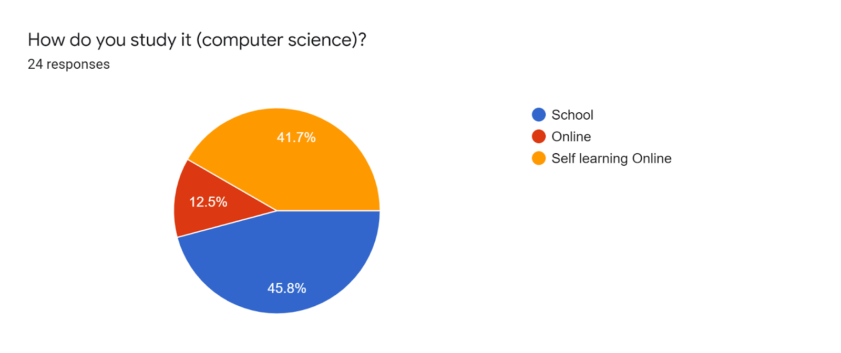

According to these results 45% of 24 students, are studying computer science in school which means they are attending classes whereas 41% of students are self-learners which refers to that they learn computer science technologies and disciplines using the free online courses that are available on the internet, whereas 12.5% of students are involved in an online program or course. We can conclude that most of the informants have a computer science background and they are in one way or another interested in the field.

**Question 2: Do you need to know English as a software developer?**

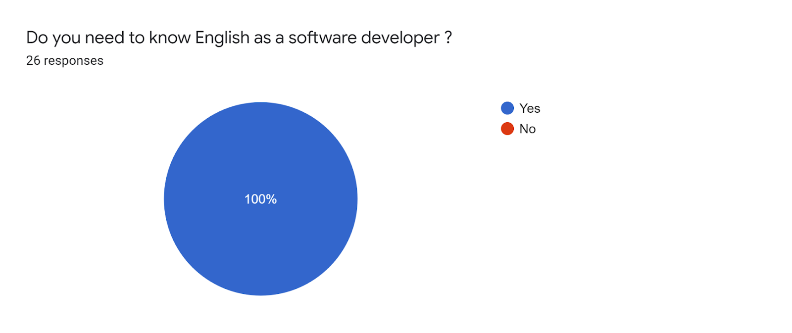

According to the results, 100% of all the 26 students respond with a positive answer, meaning that they all believe that English language skills are necessary for a software developer. Software development is a branch of computer science (Chapter 3 section). So we can say that this conviction can be a strong motivator for students to learn English and shift their focus to English more than other languages.

**Question 3: Do you think English language skills will help you in your career?**

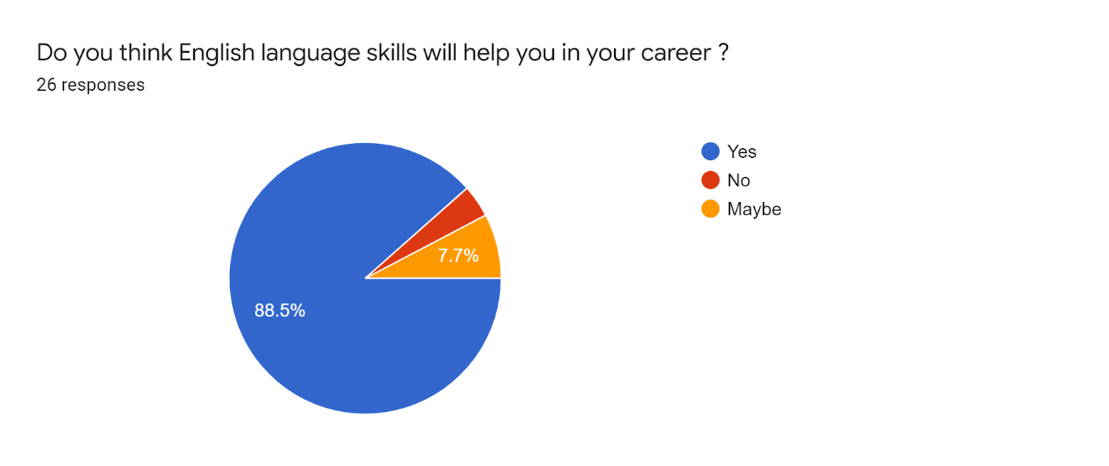

The result shows that 88.5% of students say yes, while 7.7% say maybe, and 3.8% said no. which means 23 people agree that the English language is important for perusing a successful career in the field of computer science and Information technology. From these results, we can conclude that socioeconomic factors can play a huge role in the dominance of a language. The social and economic factors are always responsible for shifting language in a society, which happens because members of a society tend to use the language that is more prestigious and powerful in a working domain. (Chapter 1, Section1).

**Question 4: What language do you use to search in Google for Coding Errors?**

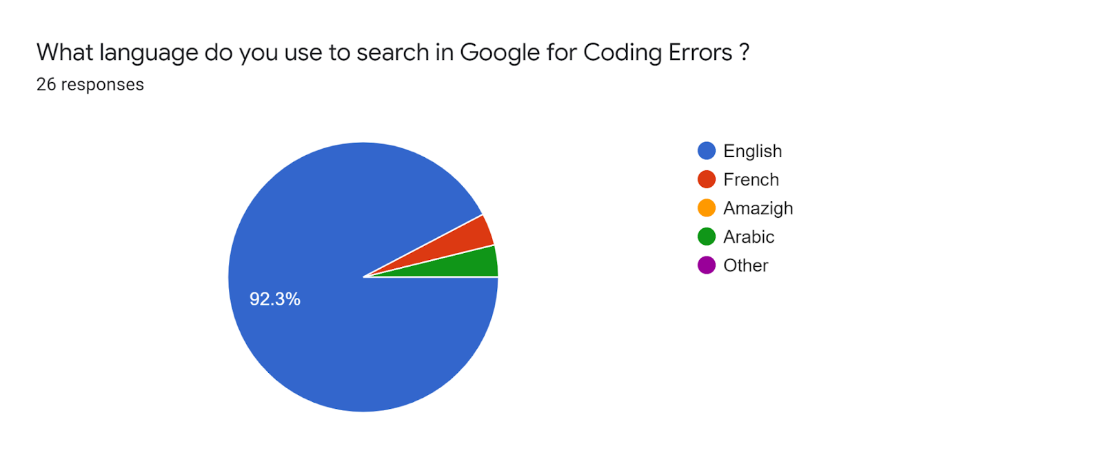

The result shows that 92% of students use English for errors solution searching in google, while 3% use Arabic and also 3% use French. As the graph also displays there are no students who use Amazigh or other languages. The result indicates that 24 of 26 students use English when they face errors in Information technologies for instance when programming or dealing with information systems. We can say that most of the computer science documentation and resources can be the reason why most of the informants prefer to use English. Again this can lead to enhancing students English skills.

**Question 4: Computer science and Information Technology help you to learn new English vocabulary?**

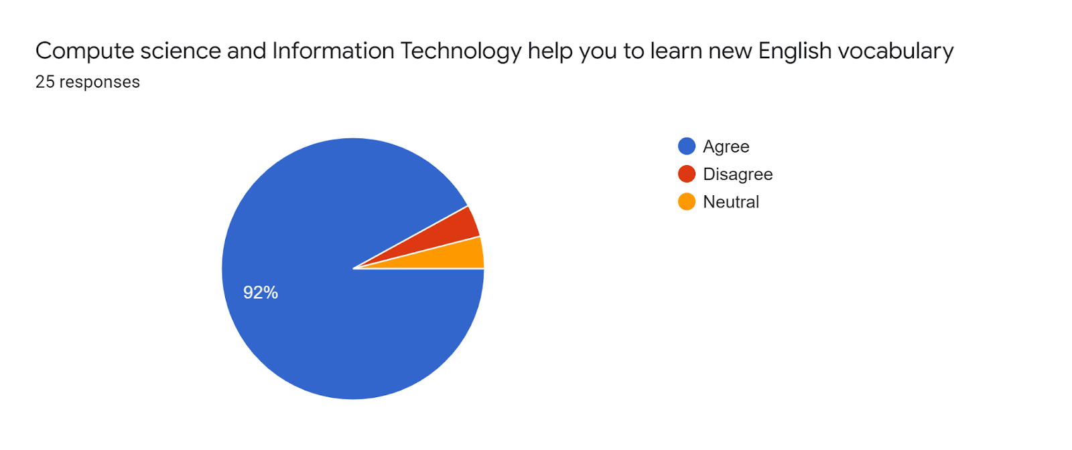

According to the results, 92% agree that studying computer science can help to learn new English vocabulary, only 4% said no and 4% are neutral. Meaning that 23 students support the idea that learning information technology and computer science disciplines can lead to acquiring more English vocabulary. These results show that studying computer science will lead to enhancing students linguistic repertoire of English.

**Question 5: what field you are more interested in computer science?**

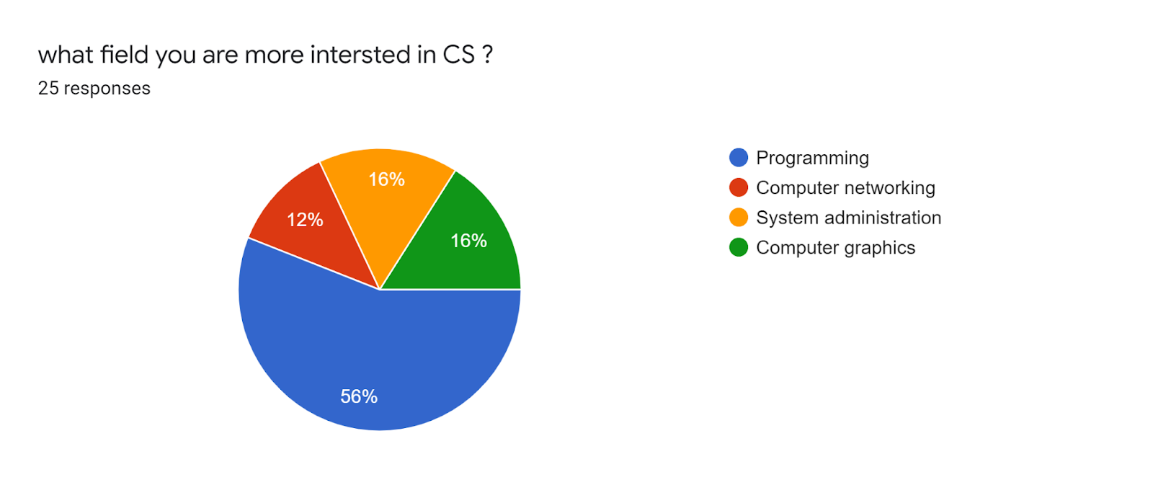

According to these 25 responses, 56% of students prefer computer programming, 16% are interested in computer graphics, 16% are interested in system administration, and 12% prefer computer networking. We can say that most students are attracted to software development like developing digital applications and graphics.

**Question 6: Do you need to learn English to get a good salary in Computer science or IT?**

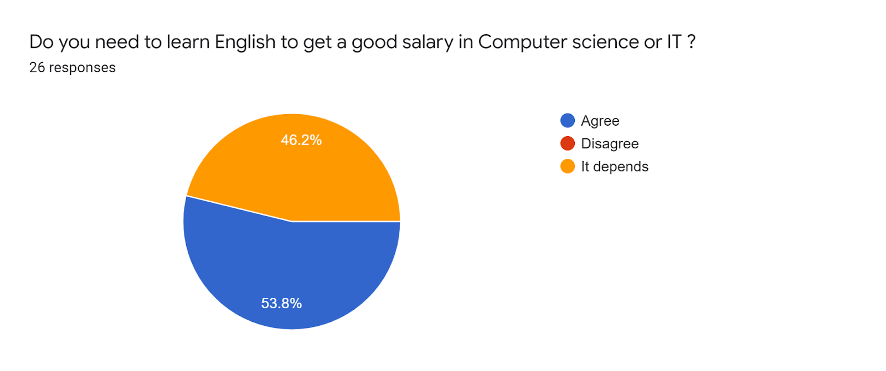

According to these results, 53% of students agree that learning English will help them get a good salary or income in their information technology career, while 46.2% said it depends. These results show that students aware about the necessity of English languages skills in the market and even those who say it depends it may be that they think computer science technical skills are more valuable than English language skills. But they say it depends on the position in the field.

**Question 7: Are you going to travel to another country if you have found a job with better salary?**

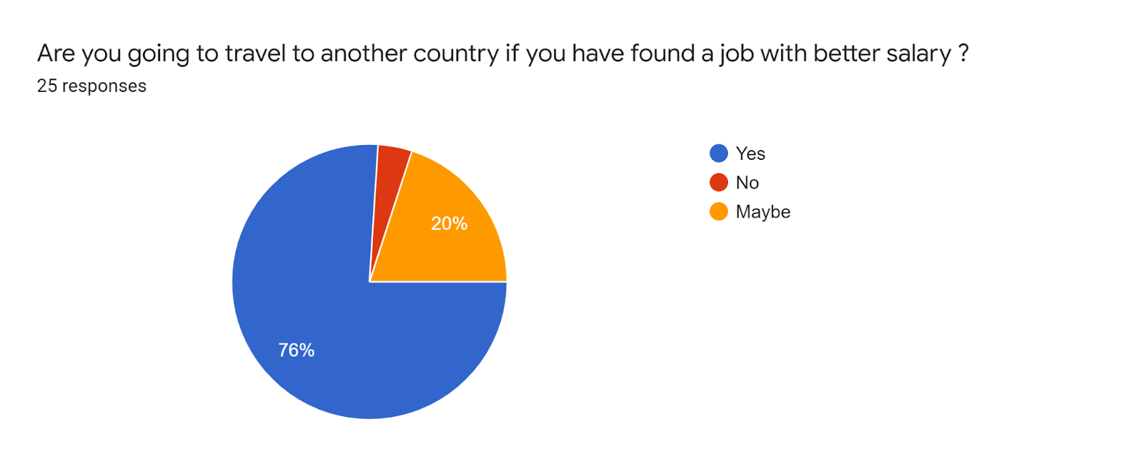

76% of students are ready to travel to other countries if they've got better income opportunities, while 20% said maybe meaning they are not sure, and 4% said no. The results show that majority of informants are ready to immigrate for a better work condition, which is a factor that influences the language shift of members of a society.

Language shift can happen in a society as a result of socioeconomic factors, which encourage members of a society to learn the more prestigious language in a business, in this situation English is the more prestigious language in the field of computer science.(Part1 chapter1section 2).

**Question 8: What language do you prefer to learn new technologies with and for tutorials online?**

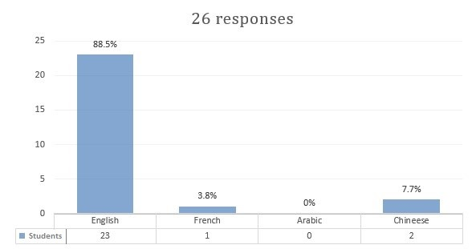

These results show that 88.5% use English language when studying new computer science materials, while 7.7% said Chinese and 3.8% use French. We can say that most all students prefer English as their language to read about technologies and materials of computer science. these refer to English as the dominant language in computer technology that students find easy to use, compared to other languages like French or Arabic which are official languages in Morocco even though they are both used in Academic fields. We can state that English is preferred by students because most online tutorials and documentation about computer science are written in English by both native and native speakers, in addition, English is the language of communication between people in this field which is like a linugua franca for them.

**Question 8: Do you need good communication skills to work in another country like USA, UK or Canada?**

According to the results, 80.8% of students agree that effective communication skills are required for work in other developed countries like USA Canada, and UK, while 19.2% of student says maybe, none of the students disagree. It is clear that most of students are aware of the importance of effective communication skills in the market.

**Question 9: Are you ready to take a Language test certificate Like IELTS or TOEFL to work outside your country?**

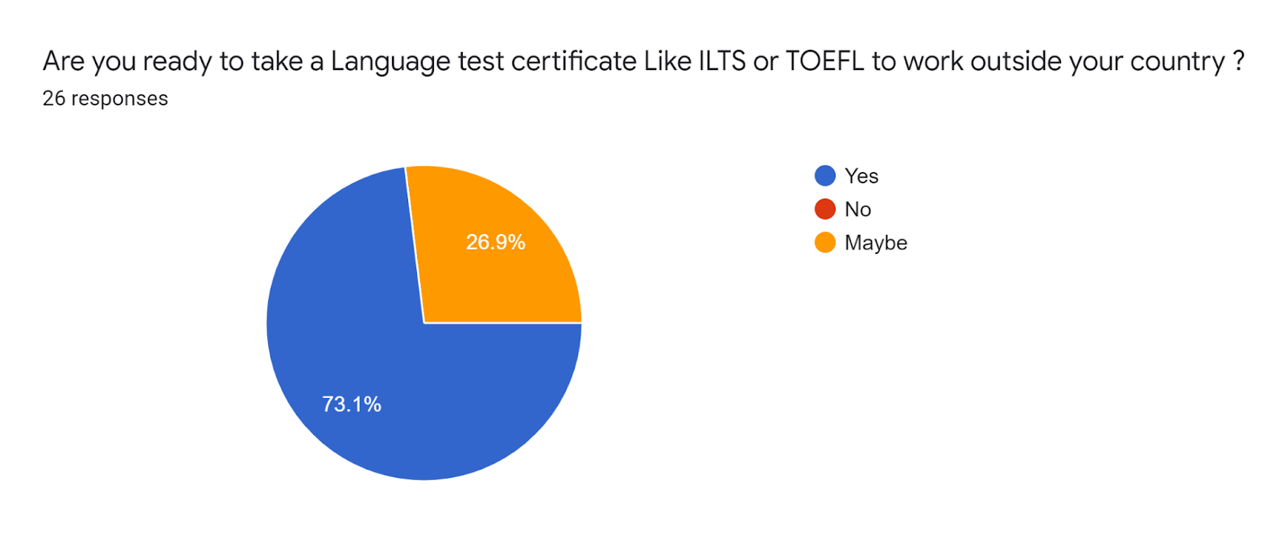

The result shows that 73% students are ready to get a language certification if required for work, like IELTS English Language Testing System or TOEFL Test of English as a Foreign Language, while 26.9% students said maybe. Now we can say that most of informants can prepare for English language certifications, which will make them enhance their skills and interest in English.

**Question 10: if you are going to continue your study after graduation what language do you like to study with?**

According to these results, 92% of students have chosen English as their language of education if they want to continue their studies, while 7.7% prefer French. We can assume English is the dominant language and the majority of students will focus more on English rather than other languages.

Works Cited

**Bibliography:**

Abbas, Jasim Mohammed. "The Impact of Technology on Modern English Language." Al-Iraqia University–College of Arts (2019).

Al Amadidhi, Darwish. "Economy as a factor in language change." (1990), pp. 7-27.

Salikoko, Sangol. Mufwene. “Language Shift - International Encyclopedia of Linguistic Anthropology - Final Revisions.” University of Chicago 2018.  
 [https://www.researchgate.net/publication/328027240](https://www.researchgate.net/publication/328027240_LANGUAGE_SHIFTINTERNATIONAL_ENCYCLOPEDIA_OF_LINGUISTIC_ANTHROPOLOGY_-_FINAL_REVISIONS)

Beaubouef, Theresa. "Why computer science students need language." ACM SIGCSE Bulletin 35.4 (2003): 51-54.

Lee, Konsbruck Robert. "Impacts of Information Technology on Society in the new Century." Business and Management 5.6 (2002): 46-55.

Panagiotidis, Panagiotis, et al. "Technology as a motivational factor in foreign language learning." European Journal of Education 1.3 (2018): 43-52.

Sri Lestari and Radius Setiyawan. ‘Technology Era, Global English, CLIL: Influence and its Impact on English Teaching for Young Learners in Indonesia.“ IOP Conference Series: Earth and Environmental Science, vol. 469, no. 012094, Apr 2022, pp. 1-8,   
 <https://iopscience.iop.org/article/10.1088/1755-1315/469/1/012094>

**Webliography:**

“8 Reasons to Study Computer Science at University”, *DePaul University* 01 June 2021, 29 Apr 2022.  
 [https://globalgateway.depaul.edu/blog/8-reasons-to-study-computer-science-at- university](https://globalgateway.depaul.edu/blog/8-reasons-to-study-computer-science-at-%09university)

Collom, Katie. “Can Economic Development Affect Language?.” *Language Trainers* 19 Aug 2020, 28 Apr 2022.  
 https://www.languagetrainers.com/blog/can-economic-development-affect- language/

“Communication Skills for Computer Science Students.” *Computer Sience Teachers Association,* 13 Apr 2009, 27 Apr 2022. [http://advocate.csteachers.org/2009/04/13/communication-skills-for-computer- science-students/](http://advocate.csteachers.org/2009/04/13/communication-skills-for-computer-%09science-students/)

“Computer Science vs. Information Technology: Careers, Degrees, and More.” *Coursera*, 15 Dec. 2021, 24 Apr 2022.

[www.coursera.org/articles/computer-science-vs-information-technology](http://www.coursera.org/articles/computer-science-vs-information-technology).

David, Maya. Khelmani. “Language Maintenance, Language shift, & Language Revitalisation - A Lecture by Prof. Maya David @CU.”, Youtube Uploaded by C U Linguistics, 26 Jan 2021. 12/04/2022.  
 <https://www.youtube.com/watch?v=OxNPlwPaxlw>

“Do I Need To Speak And Understand English Software Engineer.” *YouTube,* Uploaded by Amigoscode, 18 May 2020, 27 Apr 2022.  
 <https://www.youtube.com/watch?v=XkP6eEGAXmA>

“English As A Language of Science and Technology.” *Language Connections*, 7 Feb. 2020. 15/04/2022.  
 [www.languageconnections.com/blog/english-the-universal-language-of-science](http://www.languageconnections.com/blog/english-the-universal-language-of-science).

Jorgensen, Jayson. “Learning the Value of English as a Computer Science Major.” Reading Horizons, 13 Sep 2017, 26 Apr 2022.   
 <https://readinghorizons.website/blog/learning-the-value-of-english/>

Mandl, Jenny. “Why are all programming languages in English?” *Medium, 16 Jun 2016, 25 Apr 2022.* [https://medium.com/@jennymandl/why-are-all-programming-languages-in- english-12b1312bada4](https://medium.com/@jennymandl/why-are-all-programming-languages-in-%09english-12b1312bada4)

Mplewis. “Migration and Language Contact.”, *Ethnologue*, 1 Oct. 2015. 10/04/2022.

[https://www.ethnologue.com/ethnoblog/m-paul-lewis/migration-and-language- contact](https://www.ethnologue.com/ethnoblog/m-paul-lewis/migration-and-language-%09contact)

Nikhil, Sonnad. “Tim Cook doesn’t seem to understand that good programmers have to learn English.” *Quartz*, 12 Oct 2017, 07/04/2022

<https://qz.com/1101096/>

“Non-English-based programming languages”, *Wikipedia,* 04 Apr 2022, 23, Apr 2022.  
 <https://en.wikipedia.org/wiki/Non-English-based_programming_languages>

Nyabol, Nanjala. “What Will Be the Language of Our Digital Future?” *The nation, 15 jul 2021, 26 Apr 2022.* <https://www.thenation.com/article/society/digital-rights-language-technology/>

Sharf, Samantha. “The World's Largest Tech Companies 2016: Apple Bests Samsung, Microsoft, And Alphabet”, *Forbes,* 26 May 2016, 24, April 2022.  
 [https://www.forbes.com/sites/samanthasharf/2016/05/26/the-worlds-largest-tech  
 companies-2016-apple-bests-samsung-microsoft-and-alphabet/](https://www.forbes.com/sites/samanthasharf/2016/05/26/the-worlds-largest-tech%09companies-2016-apple-bests-samsung-microsoft-and-alphabet/)

Sreeraman Thiagarajan, “Why English is now an increasing prerequisite to enter technology driven global markets.” *The Economic Times,* 14 Nov 2017, 29 Apr 2022.  
 [https://economictimes.indiatimes.com/small-biz/security-tech/technology/why-english-is- now-an-increasing-prerequisite-to-enter-technology-driven-global- markets/articleshow/61639802.cms](https://economictimes.indiatimes.com/small-biz/security-tech/technology/why-english-is-now-an-increasing-prerequisite-to-enter-technology-driven-global-markets/articleshow/61639802.cms)

“What is Information Technology about and its growth by 2025”, *LNCT* 25 May, 2021, 26 April 2022.  
 <https://lnct.ac.in/what-is-information-technology-about/>

Yuen, Vanessa. “Programming 101: Learn English.” *YouTube,* Uploaded by EmpireJS, 24 Oct 2017, 27 Apr 2022.  
 <https://www.youtube.com/watch?v=pOwnBPaW5zE&t=3s>